**eMethods.** Supplemental methods for group-based trajectory modeling

**eTable 1.** Bayesian information criterion (BIC) values and estimated group proportions for model selection when determining the number of trajectories for main analysis (3 years pre-fracture after 5-year good adherence).

**eTable 2.** Bayesian information criterion (BIC) values and estimated group proportions for model selection when determining the number of trajectories for sensitivity analysis (2 years pre-fracture after 3-year good adherence).

**eTable 3.** Statistics for assessing model adequacy for all trialed group-based trajectory models of 3 trajectories for main analysis (3 years pre-fracture after 5-year good adherence).

**eTable 4.** Statistics for assessing model adequacy for all trialed group-based trajectory models of 3 trajectories for sensitivity analysis (2 years pre-fracture after 3-year good adherence).

**eTable 5.** Specifications of final model chosen for main analysis (3 years pre-fracture after 5-year good adherence).

**eTable 6.** Specifications of final model chosen for sensitivity analysis (2 years pre-fracture after 3-year good adherence).

**eTable 7.** STROBE Statement.

**eTable 8.** Characteristics of study cohort by oral bisphosphonate for sensitivity analysis.

**eTable 9.** Adjusted hazard ratios of post-fracture mortality for main and sensitivity analyses.

**eTable 10.** Numbers, mortality rates, absolute rate differences and adjusted hazard ratios of post-fracture mortality for different pre-fracture bisphosphonate use in sensitivity analysis.

**eFigure 1.** Study flow diagram for main analysis (3 years pre-fracture bisphosphonate use after 5-year good adherence).

**eFigure 2.** Study flow diagram for sensitivity analysis (2 years pre-fracture bisphosphonate use after 3-year good adherence).

**eFigure 3.** Group-based trajectory model for 2-year pre-fracture oral bisphosphonate use

**eFigure 4.** Kaplan-Meier curve of post-fracture mortality by individual oral bisphosphonate for sensitivity analysis.

**eReferences.**

**eMethods. Supplemental methods for group-based trajectory modeling**

As recommended by Nagin,1 we first determined the number of trajectories using the highest order for all trajectories, allowing maximum number of inflection points thus flexibility when fitting the trajectory. Bayesian information criterion (BIC) and clinical relevance were used to determine the number of groups in the model. A model with 3 trajectories was chosen because a larger number of trajectories did not provide further clinically relevant stratification (eTables 1-2). Afterwards, we explored different orders for each trajectory to determine the final best-fitting model (eTables 3-4). The decision was based on the following criteria: (a) average posterior probability of group membership >0.7, (b) odds of correct classification >5, (c) the highest order parameter of each trajectory was statistically significant, (d) the BIC, (e) parsimony principle and (f) clinical relevance.1

**eTable 1. Bayesian information criterion (BIC) values and estimated group proportions for model selection when determining the number of trajectories for main analysis (3 years pre-fracture after 5-year good adherence).**

|  |  |  |  |  |  |  |  |  |  |
| --- | --- | --- | --- | --- | --- | --- | --- | --- | --- |
| Number of trajectories | BICa | Estimated group proportions (%)b | | | | | | | |
| Group 1 | Group 2 | Group 3 | Group 4 | Group 5 | Group 6 | Group 7 | Group 8 |
| 2 | -5583.560884 | 25.3 | 74.7 |  |  |  |  |  |  |
| 3 | -5243.197031 | 14.1 | 17.4 | 68.6 |  |  |  |  |  |
| 4 | -5115.577706 | 12.6 | 13.5 | 13.5 | 60.3 |  |  |  |  |
| 5 | -5048.697555 | 11.4 | 10.9 | 5.1 | 12.1 | 60.5 |  |  |  |
| 6 | -5039.650048 | 2.7 | 13.5 | 10.1 | 5.2 | 11.8 | 56.8 |  |  |
| 7 | -5031.601251 | 4.5 | 10.7 | 6.1 | 5.1 | 8.4 | 15.6 | 49.4 |  |
| 8 | -5029.926737 | 2.3 | 4.5 | 1.1 | 17.6 | 7.8 | 9.2 | 7.1 | 50.3 |

**Abbreviations: BIC,** Bayesian information criterion.

aBayesian information criterion (BIC). Less negative BIC indicates better model fit. bEstimated proportion of individuals in each group by the model.

**eTable 2. Bayesian information criterion (BIC) values and estimated group proportions for model selection when determining the number of trajectories for sensitivity analysis (2 years pre-fracture after 3-year good adherence).**

|  |  |  |  |  |  |  |  |  |  |
| --- | --- | --- | --- | --- | --- | --- | --- | --- | --- |
| Number of trajectories | BICa | Estimated group proportions (%)b | | | | | | | |
| Group 1 | Group 2 | Group 3 | Group 4 | Group 5 | Group 6 | Group 7 | Group 8 |
| 2 | -8814.166951 | 20.4 | 79.6 |  |  |  |  |  |  |
| 3 | -8488.52125 | 9.3 | 19.5 | 71.2 |  |  |  |  |  |
| 4 | -8297.225392 | 9.4 | 15.4 | 11.2 | 64.1 |  |  |  |  |
| 5 | -8230.634565 | 14.9 | 8.8 | 7 | 6 | 63.3 |  |  |  |
| 6 | -8182.575744 | 18.1 | 2.5 | 7.6 | 7.1 | 5.7 | 59 |  |  |
| 7 | -8198.267113 | 2.2 | 4.4 | 16.2 | 2.3 | 6.1 | 9.2 | 59.6 |  |
| 8 | -8200.034649 | 2.4 | 1.3 | 0.9 | 7.5 | 7.1 | 5.5 | 18.6 | 56.8 |

**Abbreviations: BIC,** Bayesian information criterion.

aBayesian information criterion (BIC). Less negative BIC indicates better model fit. bEstimated proportion of individuals in each group by the model.

**eTable 3. Statistics for assessing model adequacy for all trialed group-based trajectory models of 3 trajectories for main analysis (3 years pre-fracture after 5-year good adherence).**

|  |  |  |  |  |  |
| --- | --- | --- | --- | --- | --- |
| Termsa | BICb | Statistics for model adequacy assessment (Estimated group proportion (%)c, proportion classified in group (%)d, average group posterior probabilitye, odds of correct classificationf) | | | Significant highest order parameter of all groupsg |
| Group 1 | Group 2 | Group 3 |
| 1 1 2 | -5240.992686 | 14.2, 14.2, 0.984, 380 | 20.0, 20.0, 0.963, 104 | 65.8, 65.8, 0.992, 65 | No |
| 1 1 3 | -5242.999692 | 14.2, 14.2, 0.982, 331 | 19.9, 19.5, 0.973, 148 | 66.0, 66.3, 0.990, 49 | Yes |
| 1 2 2 | -5245.733979 | 20.0, 20.0, 0.963, 104 | 14.2, 14.2, 0.985, 388 | 65.8, 65.8, 0.992, 64 | No |
| 1 2 3 | -5247.740827 | 19.9, 19.5, 0.974, 148 | 14.1, 14.2, 0.982, 324 | 66.0, 66.3, 0.990, 50 | No |
| 1 2 4 | -5247.337932 | 19.8, 19.5, 0.971, 136 | 14.1, 14.2, 0.980, 292 | 66.1, 66.3, 0.991, 54 | No |
| 2 2 2 | -5240.076433 | 14.2, 14.2, 0.983, 345 | 18.1, 18.1, 0.972, 159 | 67.7, 67.7, 0.996, 111 | No |
| 2 2 3 | -5239.988418 | 14.4, 14.2, 0.996, 1356 | 16.4, 16.4,0.973, 186 | 69.2, 69.3, 0.995, 92 | Yes |
| 2 2 4 | -5239.099697 | 14.1, 14.2, 0.979, 278 | 17.8, 17.8, 0.973, 165 | 68.1, 67.9, 0.997, 165 | No |
| 2 3 3 | -5242.199858 | 17.5, 17.5, 0.972, 161 | 14.4, 14.5, 0.983, 337 | 68.1, 67.9, 0.997, 176 | Yes |
| 2 3 4 | -5240.429513 | 17.4, 17.5, 0.968, 144 | 14.4, 14.5, 0.982, 317 | 68.2, 67.9, 0.998, 208 | Yes |
| 3 3 3 | -5236.231791 | 14.5, 14.2, 0.998, 2965 | 16.7, 17.0, 0.962, 127 | 68.8, 68.8, 0.995, 93 | Yes |
| **3 3 4\*** | **-5233.927338** | **14.0, 13.7, 0.998, 3158** | **17.5, 17.5, 0.971, 160** | **68.6, 68.8, 0.994, 74** | **Yes** |
| 3 4 4 | -5238.497351 | 17.4, 17.5, 0.968, 142 | 14.0, 13.7, 0.998, 3920 | 68.5, 68.8, 0.994,71 | No |
| 4 4 4 | -5243.197031 | 14.1, 13.7, 0.999, 4106 | 17.4, 17.5, 0.966, 135 | 68.6, 68.8, 0.994, 76 | No |

**Abbreviations: BIC,** Bayesian information criterion.

aOrder of each trajectory in the model. 1=linear, 2=quadratic, 3=cubic, 4=quartic. bBayesian information criterion (BIC). Less negative BIC indicates better model fit. cEstimated proportion of individuals in each group by the model. dActual proportion of individuals classified in each group, based on maximum posterior probability of group membership. It should be similar to estimated group proportions. eAverage posterior probability of group membership for each group should be >0.7 to indicate good precision in classifying individuals. fOdds of correct classification based on posterior probabilities of group membership should be greater than 5 to indicate clear distinction between groups. gHighest order parameters of each group should be significant. *Final model selected.

**eTable 4. Statistics for assessing model adequacy for all trialed group-based trajectory models of 3 trajectories for sensitivity analysis (2 years pre-fracture after 3-year good adherence).**

|  |  |  |  |  |  |
| --- | --- | --- | --- | --- | --- |
| Termsa | BICb | Statistics for model adequacy assessment (Estimated group proportion (%)c, proportion classified in group (%)d, average group posterior probabilitye, odds of correct classificationf) | | | Significant highest order parameter of all groupsg |
| Group 1 | Group 2 | Group 3 |
| **1 1 2\*** | **-8508.789296** | **9.9, 9.5, 0.979, 426** | **20.4, 20.5, 0.910, 40** | **69.8, 70.0, 0.979, 20** | **Yes** |
| 1 1 3 | -8512.541129 | 9.9, 9.5, 0.979, 434 | 20.4, 20.5, 0.912, 40 | 69.7, 70.0, 0.979, 20 | Νο |
| 1 2 2 | -8512.07068 | 20.1, 20.0, 0.922, 47 | 9.4, 9.2, 0.979, ΛΛΑ | 70.5, 70.8, 0.979, 19 | Νο |
| 1 2 3 | -8515.855355 | 20.2, 20.3, 0.917, 44 | 9.4, 9.2, 0.979, 454 | 70.4, 70.5, 0.980,21 | Νο |
| 1 2 4 | -8520.48339 | 20.2, 19.8, 0.926, 50 | 9.4, 9.4, 0.968, 291 | 70.4, 70.7, 0.979, 19 | Νο |
| 2 2 2 | -8491.075288 | 19.5, 19.6, 0.924, 50 | 9.6, 9.5, 0.972, 324 | 70.9, 70.8, 0.984, 26 | Νο |
| 2 2 3 | -8481.385961 | 11.3, 11.3, 0.975, 300 | 12.4, 12.2, 0.956, 154 | 76.2, 76.5, 0.992, 37 | Νο |
| 2 2 4 | -8499.050923 | 9.6, 9.5, 0.972, 328 | 19.5, 19.6, 0.924, 50 | 70.9, 70.8, 0.984, 26 | Νο |
| 2 3 3 | -8482.119838 | 19.6, 19.6, 0.928, 53 | 9.5, 9.3, 0.982, 517 | 70.9, 71.1, 0.983, 24 | Νο |
| 2 3 4 | -8486.709127 | 19.6, 19.8, 0.924, 50 | 9.5, 9.3, 0.982, 514 | 70.9, 70.8, 0.985, 26 | Νο |
| 3 3 3 | -8478.178924 | 9.3, 9.3, 0.971, 330 | 19.8, 19.6, 0.931, 55 | 71.0, 71.1, 0.983, 23 | Νο |
| 3 3 4 | -8482.755936 | 9.3, 9.3, 0.971, 329 | 19.7, 19.7, 0.929, 53 | 71.0, 71.0, 0.984,25 | Νο |
| 3 4 4 | -8486.983111 | 19.6, 19.6, 0.927,52 | 9.3, 9.3, 0.968, 297 | 71.1, 71.1, 0.984,25 | Νο |
| 4 4 4 | -8488.52125 | 9.3, 9.2, 0.978, 431 | 19.5, 19.6, 0.926, 51 | 71.2, 71.2, 0.984, 25 | Νο |

**Abbreviations: BIC,** Bayesian information criterion.

aOrder of each trajectory in the model. 1=linear, 2=quadratic, 3=cubic, 4=quartic. bBayesian information criterion (BIC). Less negative BIC indicates better model fit. cEstimated proportion of individuals in each group by the model. dActual proportion of individuals classified in each group, based on maximum posterior probability of group membership. It should be similar to estimated group proportions. eAverage posterior probability of group membership for each group should be >0.7 to indicate good precision in classifying individuals. fOdds of correct classification based on posterior probabilities of group membership should be greater than 5 to indicate clear distinction between groups. gHighest order parameters of each group should be significant. *Final model selected.

**eTable 5. Specifications of final model chosen for main analysis (3 years pre-fracture after 5-year good adherence).**

|  |  |  |  |  |
| --- | --- | --- | --- | --- |
|  | Group size | Model estimate of group proportion | Average group posterior probability | Odds of correct classification |
| Discontinued for 2 years | 50 | 0.1395944 | 0.9980520 | 3158 |
| Discontinued for 1 year | 64 | 0.1747989 | 0.9712604 | 160 |
| Continued use | 251 | 0.6856067 | 0.9938505 | 74 |

**eTable 6. Specifications of final model chosen for sensitivity analysis (2 years pre-fracture after 3-year good adherence).**

|  |  |  |  |  |
| --- | --- | --- | --- | --- |
|  | Group size | Model estimate of group proportion | Average group posterior probability | Odds of correct classification |
| Discontinued for 1 year | 86 | 0.09877804 | 0.9790080 | 425 |
| Discontinued for less than 1 year | 185 | 0.20351489 | 0.9102282 | 40 |
| Continued use | 631 | 0.69770707 | 0.9788056 | 20 |

**eTable 7. STROBE Statement.**

|  |  |  |  |  |
| --- | --- | --- | --- | --- |
|  | Item No | Recommendation | Page No | Relevant text from manuscript |
| **Title and abstract** | 1 | (*a*) Indicate the study’s design with a commonly used term in the title or the abstract | 1,3 | Abstract |
| (*b*) Provide in the abstract an informative and balanced summary of what was done and what was found | 3 | Abstract |
| Introduction | | |  |  |
| Background/rationale | 2 | Explain the scientific background and rationale for the investigation being reported | 4 | Introduction, paragraphs 1-4 |
| Objectives | 3 | State specific objectives, including any prespecified hypotheses | 4 | Introduction, paragraph 5 |
| Methods | | |  |  |
| Study design | 4 | Present key elements of study design early in the paper | 4 | Methods, first sentence |
| Setting | 5 | Describe the setting, locations, and relevant dates, including periods of recruitment, exposure, follow-up, and data collection | 4-6 | Methods, paragraphs 1-4 |
| Participants | 6 | (*a*) *Cohort study*—Give the eligibility criteria, and the sources and methods of selection of participants. Describe methods of follow-up  *Case-control study*—Give the eligibility criteria, and the sources and methods of case ascertainment and control selection. Give the rationale for the choice of cases and controls  *Cross-sectional study*—Give the eligibility criteria, and the sources and methods of selection of participants | 4-6 | Methods, paragraphs 1-4 |
| (*b*)*Cohort study*—For matched studies, give matching criteria and number of exposed and unexposed  *Case-control study*—For matched studies, give matching criteria and the number of controls per case | NA |  |
| Variables | 7 | Clearly define all outcomes, exposures, predictors, potential confounders, and effect modifiers. Give diagnostic criteria, if applicable | 5,6 | Methods, paragraphs 4-6 |
| Data sources/ measurement | 8* | For each variable of interest, give sources of data and details of methods of assessment (measurement). Describe comparability of assessment methods if there is more than one group | 6 | Methods, paragraph 6 |
| Bias | 9 | Describe any efforts to address potential sources of bias | 6 | Methods, paragraph 6 |
| Study size | 10 | Explain how the study size was arrived at | 5 | Methods, paragraph 2 |
| Quantitative variables | 11 | Explain how quantitative variables were handled in the analyses. If applicable, describe which groupings were chosen and why | 6 | Methods, paragraph 6 |
| Statistical methods | 12 | (*a*) Describe all statistical methods, including those used to control for confounding | 6 | Methods, paragraph 6 |
| (*b*) Describe any methods used to examine subgroups and interactions | 6 | Methods, paragraph 6 |
| (*c*) Explain how missing data were addressed | 5 | Methods, paragraphs 1 |
| (*d*) *Cohort study*—If applicable, explain how loss to follow-up was addressed  *Case-control study*—If applicable, explain how matching of cases and controls was addressed  *Cross-sectional study*—If applicable, describe analytical methods taking account of sampling strategy | 5 | Methods, paragraph 2 |
| (*e*) Describe any sensitivity analyses | NA |  |
| Results | | |  |  |
| Participants | 13* | (a) Report numbers of individuals at each stage of study—eg numbers potentially eligible, examined for eligibility, confirmed eligible, included in the study, completing follow-up, and analysed | 6,7, Appendix | Results, paragraph 1. eFigures 1-2. |
| (b) Give reasons for non-participation at each stage | Appendix | eFigures 1-2 |
| (c) Consider use of a flow diagram | Appendix | eFigures 1-2 |
| Descriptive data | 14* | (a) Give characteristics of study participants (eg demographic, clinical, social) and information on exposures and potential confounders | Table, Figure | Table 1, Figure 2 |
| (b) Indicate number of participants with missing data for each variable of interest | NA |  |
| (c) *Cohort study*—Summarise follow-up time (eg, average and total amount) | Table | Table 2 |
| Outcome data | 15* | *Cohort study*—Report numbers of outcome events or summary measures over time | 7, Table | Results, paragraphs 3; Table 2. |
| *Case-control study—*Report numbers in each exposure category, or summary measures of exposure | NA |  |
| *Cross-sectional study—*Report numbers of outcome events or summary measures | NA |  |
| Main results | 16 | (*a*) Give unadjusted estimates and, if applicable, confounder-adjusted estimates and their precision (eg, 95% confidence interval). Make clear which confounders were adjusted for and why they were included | Table, Appendix | Tables 2, eTable 8. |
| (*b*) Report category boundaries when continuous variables were categorized | 6 | Methods, paragraph 6 |
| (*c*) If relevant, consider translating estimates of relative risk into absolute risk for a meaningful time period | NA |  |
| Other analyses | 17 | Report other analyses done—eg analyses of subgroups and interactions, and sensitivity analyses | 7, Appendix | Results, paragraph 3; eFigure 2, eTables, 7-10 |
| Discussion | | |  |  |
| Key results | 18 | Summarise key results with reference to study objectives | 7,8 | Discussion, paragraph 1 |
| Limitations | 19 | Discuss limitations of the study, taking into account sources of potential bias or imprecision. Discuss both direction and magnitude of any potential bias | 9 | Discussion, paragraph 7 |
| Interpretation | 20 | Give a cautious overall interpretation of results considering objectives, limitations, multiplicity of analyses, results from similar studies, and other relevant evidence | 9 | Discussion, paragraph 8 |
| Generalisability | 21 | Discuss the generalisability (external validity) of the study results | 9 | Discussion, paragraph 7 |
| Other information | | |  |  |
| Funding | 22 | Give the source of funding and the role of the funders for the present study and, if applicable, for the original study on which the present article is based | 6 | Methods, paragraph 7 |

*Give information separately for cases and controls in case-control studies and, if applicable, for exposed and unexposed groups in cohort and cross-sectional studies.

**Note:** An Explanation and Elaboration article discusses each checklist item and gives methodological background and published examples of transparent reporting. The STROBE checklist is best used in conjunction with this article (freely available on the Web sites of PLoS Medicine at http://www.plosmedicine.org/, Annals of Internal Medicine at http://www.annals.org/, and Epidemiology at http://www.epidem.com/). Information on the STROBE Initiative is available at www.strobe-statement.org.

**eTable 8. Characteristics of study cohort by oral bisphosphonate for sensitivity analysis.a**

|  |  |  |  |
| --- | --- | --- | --- |
|  | Overall (n = 902) | Alendronate (n=553) | Risedronate (n=349) |
| Age, n (%) |  |  |  |
| 50-64 | 12 (1.3) | 5 (0.9) | 7 (2.0) |
| 65-74 | 80 (8.9) | 50 (9) | 30 (8.6) |
| 75-84 | 322 (35.7) | 193 (34.9) | 129 (37.0) |
| 85 | 488 (54.1) | 305 (55.2) | 183 (52.4) |
| Sex, n (%) |  |  |  |
| Males | 104 (11.5) | 58 (10.5) | 46 (13.2) |
| Females | 798 (88.5) | 495 (47.1) | 303 (86.8) |
| Year |  |  |  |
| 2012-13 | 166 (18.4) | 113 (20.4) | 53 (15.2) |
| 2013-14 | 180 (20.0) | 121 (21.9) | 59 (16.9) |
| 2014-15 | 152 (16.9) | 96 (17.4) | 56 (16.0) |
| 2015-16 | 155 (17.2) | 89 (16.1) | 66 (18.9) |
| 2016-17 | 149 (16.5) | 84 (15.2) | 65 (18.6) |
| 2017-18 | 100 (11.1) | 50 (9.0) | 50 (14.3) |
| Admitted from, n (%) |  |  |  |
| RACF | 59 (6.5) | 36 (6.5) | 23 (6.6) |
| Home-dwelling and otherb | 843 (93.5) | 517 (93.5) | 326 (14.2) |
| Discharged to, n (%) |  |  |  |
| RACF | 160 (17.7) | 107 (19.3) | 53 (15.2) |
| Home-dwelling and otherb | 742 (82.3) | 446 (80.7) | 296 (84.8) |
| HFRS, n (%) |  |  |  |
| 0 | 345 (38.2) | 216 (39.1) | 129 (37.0) |
| >0 and <5 | 348 (38.6) | 211 (38.2) | 137 (39.3) |
| 5-15 | 191 (21.2) | 116 (21.0) | 75 (21.5) |
| >15 | 18 (2.0) | 10 (1.8) | 8 (2.3) |
| Region of residence, n (%)c |  |  |  |
| Metropolitan | 638 (70.7) | 381 (68.9) | 257 (73.6) |
| Non-metropolitan | 264 (29.3) | 172 (31.1) | 92 (26.4) |

**Abbreviations: HFRS**, Hospital Frailty Risk Score; **RACF**, residential aged care facilities.   
a Suppression of small population (i.e. conversion of small numbers to number ranges) is required by Australian Institute of Health and Welfare. bIncluding admitted from/discharge to private residences, transition care program, mental health accommodation and transfers from other health care organizations. cBased on Department of Health Human Services Region classification. Areas classified as Eastern metropolitan, Southern metropolitan, North-western metropolitan were categorized as metropolitan, while all other regions were categorized as non-metropolitan.

**eTable 9. Adjusted hazard ratios of post-fracture mortality for main and sensitivity analyses.**

|  |  |  |
| --- | --- | --- |
|  | Main analysisa | Sensitivity analysisb |
| Hazard ratioc (HR [95% CI]) | Hazard ratioc (HR [95% CI]) |
| Type of bisphosphonate |  |  |
| Alendronate | 1 | 1 |
| Risedronate | 0.75 [0.48, 1.19] | 0.82 [0.64, 1.06] |
| Bisphosphonate use |  |  |
| Continued use | 1 | 1 |
| Discontinued for less than 1 year | N.A. | 1.02 [0.65, 1.59] |
| Discontinued for 1 year | 1.13 [0.63, 2.03] | 1.03 [0.77,1.39] |
| Discontinued for 2 years | 0.66 [0.35, 1.27] | N.A. |
| Interaction term (bisphosphonate type and use) |  |  |
| Discontinued for less than 1 year : risedronate | N.A. | 1.69 [0.88, 3.25] |
| Discontinued for 1 year : risedronate | 2.52 [1.01, 6.26] | 1.14 [0.70, 1.87] |
| Discontinued for 2 years : risedronate | 3.45 [1.43, 8.34] | N.A. |
| Age |  |  |
| 50-64 | 1 | 1 |
| 65-74 | 1.27 [0.14, 11.87] | 5.48 [0.73, 41.26] |
| 75-84 | 2.16 [0.28, 16.64] | 7.38 [1.01, 53.67] |
| 85 | 4.92 [0.65, 37.40] | 15.96 [2.20, 115.85] |
| Sex |  |  |
| Females | 1 | 1 |
| Males | 1.60 [0.98, 2.62] | 1.77 [1.32, 2.36] |
| Year |  |  |
| 2012-13 | N.A. | 1 |
| 2013-14 | N.A. | 0.92 [0.69,1.21] |
| 2014-15 | 1 | 0.82 [0.61, 1.12] |
| 2015-16 | 1.45 [0.91, 2.33] | 0.91 [0.66, 1 26] |
| 2016-17 | 1.38 [0.83, 2.30] | 0.94 [0.65, 1.35] |
| 2017-18 | 1.35 [0.67, 2.71] | 0.77 [0.44, 1.33] |
| Admitted from |  |  |
| Home-dwelling and otherd | 1 | 1 |
| RACF | 2.68 [1.65,4.34] | 1.80 [1.29, 2.53] |
| HFRS |  |  |
| 0 | 1 | 1 |
| >0 and <5 | 1.39 [0.90, 2.14] | 1.11 [0.88, 1.41] |
| 5-15 | 2.22 [1.39, 3.54] | 1.81 [1.40, 2.32] |
| >15 | 1.33 [0.31, 5.71] | 2.27 [1.18, 4 37] |
| Region of residencee |  |  |
| Metropolitan | 1 | 1 |
| Non-metropolitan | 1.04 [0.71, 1.52] | 1.02 [0.82, 1.26] |

**Abbreviations: CI**, confidence interval; **HFRS**, Hospital Frailty Risk Score; **HR**, hazard ratio; **RACF**, residential aged care facilities. aMain analysis is for assessing bisphosphonate use 36-month pre-fracture with 60-month good adherence (medication possession ratio [MPR] 80%).  aSensitivity analysis is for assessing bisphosphonate use 36-month pre-fracture with 60-month good adherence (medication possession ratio [MPR] 80%). cAdjusted for year of fracture, sex, age, hospital frailty risk score, type and region of residence, type of oral bisphosphonates, and interaction term between different bisphosphonate use trajectories and type of oral bisphosphonates. bIncluding admitted from/discharge to private residences, transition care program, mental health accommodation and transfers from other health care organizations. cBased on Department of Health Human Services Region classification.

**eTable 10. Numbers, mortality rates, absolute rate differences and adjusted hazard ratios of post-fracture mortality for different pre-fracture bisphosphonate use in sensitivity analysis.**

|  |  |  |  |  |  |  |
| --- | --- | --- | --- | --- | --- | --- |
|  | Number of death | Number of individuals | Days of follow-upa  (median [IQR]) | Mortality rate  (MR/100 PY [95% CI]) | Absolute rate difference (RD/100 PY [95% CI]) | Hazard ratiob  (HR [95% CI]) |
| Overall |  |  |  |  |  |  |
| Continued use | 277 | 631 | 718 (288-1265.5) | 19.6 [17.2 - 21.9] | 0 | 1 |
| Discontinued for less than 1 year | 94 | 86 | 761 (202-1388) | 22.5 [18.0 - 27.1] | 2.96 [-2.14 - 8.06] | 1.03 [0.77, 1.39] |
| Discontinued for 1 year | 43 | 185 | 414.5 (156.25-1165.25) | 27.6 [19.4 - 35.9] | 8.04 [-0.52 - 16.61] | 1.02 [0.65, 1.59] |
| Alendronate |  |  |  |  |  |  |
| Continued use | 187 | 389 | 741 (317-1317) | 20.7 [17.8 - 23.7] | 0 | 1 |
| Discontinued for less than 1 year | 60 | 51 | 813 (223-1442) | 22.5 [16.8 - 28.2] | 1.74 [-4.68 - 8.15] | 1.03 [0.77, 1.39] |
| Discontinued for 1 year | 23 | 113 | 410 (156.5-1189) | 24.0 [14.2 - 33.8] | 3.24 [-7.00 - 13.49] | 1.03 [0.65, 1.61] |
| Risedronate |  |  |  |  |  |  |
| Continued use | 90 | 242 | 662 (248.75-1187) | 17.5 [13.9 - 21.1] | 0 | 1 |
| Discontinued for less than 1 year | 34 | 35 | 704.5 (183-1123) | 22.6 [15.0 - 30.2] | 5.10 [-3.31 - 13.50] | 1.18 [0.78, 1.78] |
| Discontinued for 1 year | 20 | 72 | 419 (143.5-916) | 33.4 [18.8- 48.0] | 15.91 [0.83 - 30.98] | 1.66 [1.01, 2.73] |

**Abbreviations: CI**, confidence interval; **HR**, hazard ratio; **IQR**, interquartile range; **IR**, incidence rate; **PY**, person-year; **RD**, rate difference. aDays of follow-up are the number of days from admission to date of death or end of study, whichever occurred earlier. bAdjusted for year of fracture, sex, age, hospital frailty risk score, type and region of residence, type of oral bisphosphonates, and interaction term between different bisphosphonate use trajectories and type of oral bisphosphonates.

**eFigure 1. Study flow diagram for main analysis (3 years pre-fracture bisphosphonate use after 5-year good adherence).** aHistory was ascertained by diagnosis recorded within 5 years prior to admission. bOsteoporosis medications not of interest included denosumab, zoledronic acid, strontium, raloxifene, hormonal replacement therapy for females

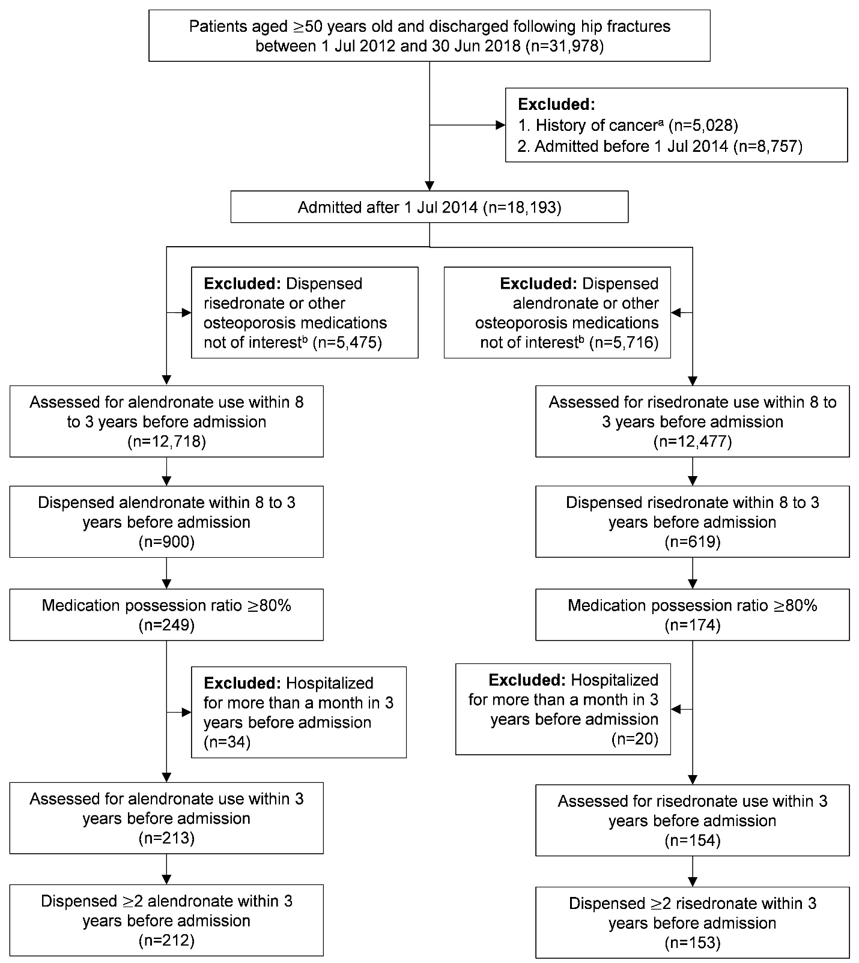

**eFigure 2. Study flow diagram for sensitivity analysis (2 years pre-fracture bisphosphonate use after 3-year good adherence).** aHistory was ascertained by diagnosis recorded within 5 years prior to admission. bOsteoporosis medications not of interest included denosumab, zoledronic acid, strontium, raloxifene, hormonal replacement therapy for females

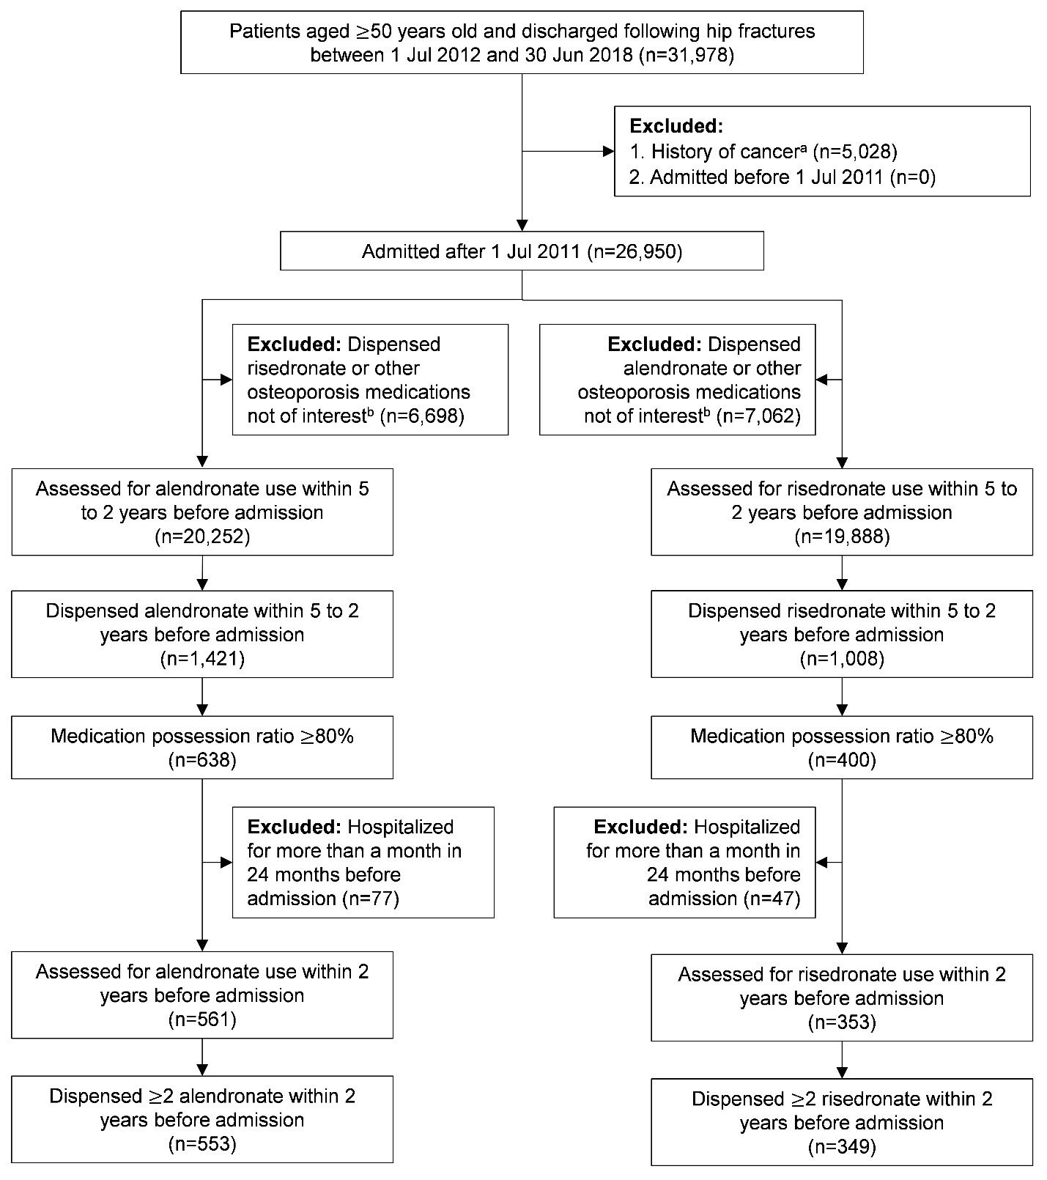

**eFigure 3. Group-based trajectory model for 2-year pre-fracture oral bisphosphonate use.**

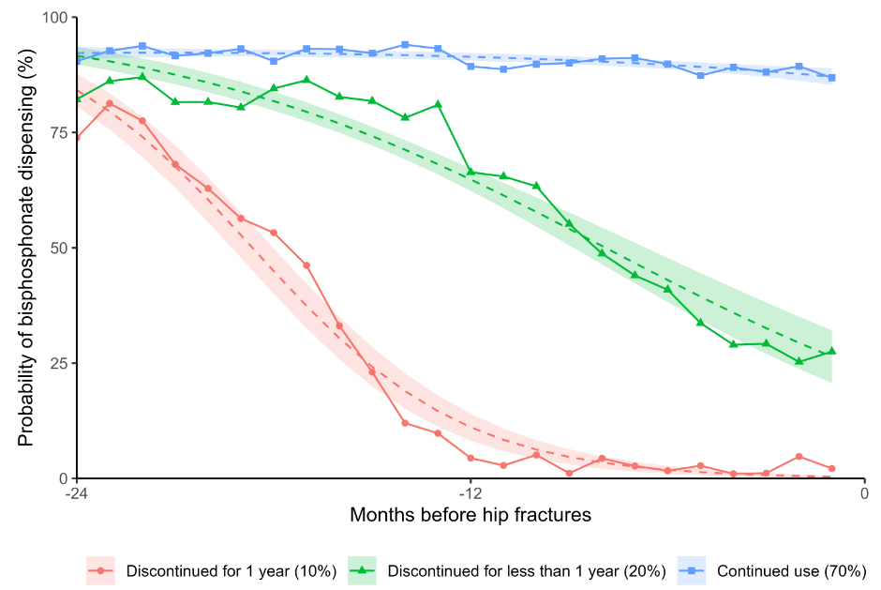

**eFigure 4. Kaplan-Meier curve of post-fracture mortality by individual oral bisphosphonate for sensitivity analysis.p = p-value of log-rank test.**

**eReferences**

1. Nagin DS. *Group-Based Modeling of Development*. Harvard University Press; 2005.